University of Regina

ENSE 400/477



**Project Night Terror Test Plan & Execution**



*Author: Advisor:*

Evan Geissler Dr. Christine Chan



Last Modified

February 24, 2019

**Revision History**

**Revision Version Date**

Version 1 February 24, 2019

Version 2 March 30, 2019

**Table of Contents**

**1 Introduction………………………………………………………………………………….…......1**

1.1 Purpose.............................………………………………..………………..............………....1

1.2 Things to Test...................................……………………………………….............…...…1

1.3 Test Level...................................……………………………………….........…...….............2

**2 Usability Testing..........………….………………...…………….....……………………………3**

2.1 Purpose & Breakdown………...…………….....………………........…......................…3

2.2 Demographics.………………...…………….....……………..............................................4

2.3 Testing Results.………………...…………….....……………………………......................4

2.5 User Feedback.……………...…………….....………………………….................…

**3 White Box Testing..........……….………………...…………….....……………………………**

3.1 Purpose & Breakdown.………………...…………….....………………........……

3.2 Tests Performed.………………...…………….....…………….........

**4 Black Box Testing..........……….………………...…………….....……………………………**

4.1 Purpose & Breakdown.………………...…………….....………………........……

4.2 Tests Performed.………………...…………….....…………….........

**5 Automated Testing..........……….…………...…………….....……………………………**

5.1 Purpose & Breakdown.………………...…………….....………………........……

**List of Figures**

Figure 1.3-1. Entire Testing Level…………………………………………………................................2

Figure 1.3-2. Test Level: Character & Light Areas………………………………..........................3

Figure 1.3-3. Test Level: Collectables & Modified Atlantic Wall Areas…..........................3

Figure 1.3-2. ………………………………………………….......................

Figure 1.3-3. …………………………………………………....................

**List of Tables**

***Table 3.1-1. White Box Testing List***

Table 3.1-1. White Box Testing List…….....…………………………………………………......

Table 3.2-1. Rifle Reload Function Test…….....…………………………………………………......

Table 4.1-1. Black Box Testing List…….....…………………………………………………......

**Appendices**

**A Usability Tests…………………………………………………………………………….…......**

**B White Box Tests………………………………………………………………….…......**

**C Black Box Tests…………………………………………………………………………….…......**

**1 Introduction**

* 1. **Purpose**

The purpose of this section is to outline and summarize the testing processes used for Project Night Terror. The focus of the testing will be to ensure gameplay and functionality for the player works well, is desirable, usable, and playable. The testing will also help to fine tune variables involved with the player and Non-Playable Characters (NPCs).

It is important to note that there is a lot of minor and quick testing done during development as added functionally and minor changes are always tried before moving on. By doing this, I am able to detect and fix problems or bugs sooner. This also allows fine-tuning some variables better earlier on. Problems or bugs that are not resolved right away will often be left till later, but will be documented in GitHub under issues. This section will not show every case test and the appendices and GitHub issues/documents should be refereed to for more information.

**1.2 Things to Test**

**Gameplay**

Gameplay includes player movement (such as jumping, running, etc.) and anything not listed below.

**AI**

Testing for AI is to test every NPC. This will involve testing that animations flow well; testing that AI will respond and attack properly; that the AI will roam properly and in predefined bounds; and testing specific AI variables such as health, damage, and that attack speed are working properly. The testing methods used to test the AI will include black/white box testing and also usability testing.

**Items**

Item testing includes the user’s flashlight, rifle, pistol, knife, and cross. The purpose of testing items is to ensure that the game does not become too easy or hard with bad variable values or mechanics; to ensure that animations and general look of items makes sense and looks good; and to ensure that the items follow good general usability ideas. This will be done with black/white box testing and also usability testing.

**Collectables**

Testing the collectables includes ensuring that their text displays properly, that audio files play properly, and that picking them up adds to the player’s inventory properly. This will mostly be done with white box testing, but usability testing will also be used.

**Saving & Loading**

Testing saving and loading is important so the user can save and leave the game; so the user can come back to the game and pick up where they left off; and to ensure that the player’s progress is saved while moving across levels. There are many different variables that need to be saved or loaded and white/black box and usability testing will be used to test it.

**Levels**

Level testing includes going from one level to the next, ensuring that there are little to no bugs in map design (such as clipping, level holes, lighting issues, etc.), and to ensure that level traversal by the player is smooth (for example, stairs should by walked on without getting stuck). This will be done usability testing and black box testing.

**User Interfaces**

User interfaces (UI) include the heads up display (HUD), the main menu, pause menus, item menus, and the sub menus within these. It is important to see if the interfaces are visually appealing, if the functionally works, and if usability is present.

* 1. **Test Level**

A test level, that is not accessible to the player, was created very early in development to allow quick and easy testing. From early movement to working with AI, the testing map allows a large multitude of functions and features to be tried, displayed, refereed to, and more. The test level also saves time by not having to move parts that would need to be moved on a playable level or by having to build the level’s lighting. Finally, there is no reason to remove items from the level as the different parts can be added to specific areas and left until needed or indefinitely. Figures 1.3-1 to Figure 1.3-3 show samples of the test level. It is important to note that features in the testing level may or may not be used in the game and is often where unused features can be seen. For example, in Figure 1.3-3 the area used to test demon AI was originally designed to view and see wooden ramps, hedgehogs, and other parts of the Atlantic Wall from WWII; a level that was originally planned early in development, but scraped in the first few months of development.

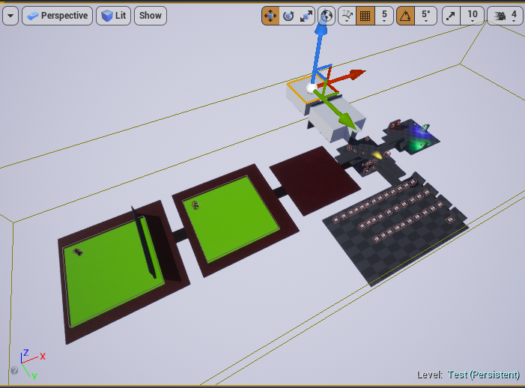

***Figure 1.3-1. Entire Testing Level***

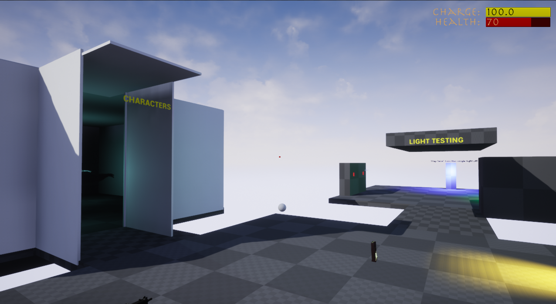

***Figure 1.3-2. Test Level: Character & Light Areas***

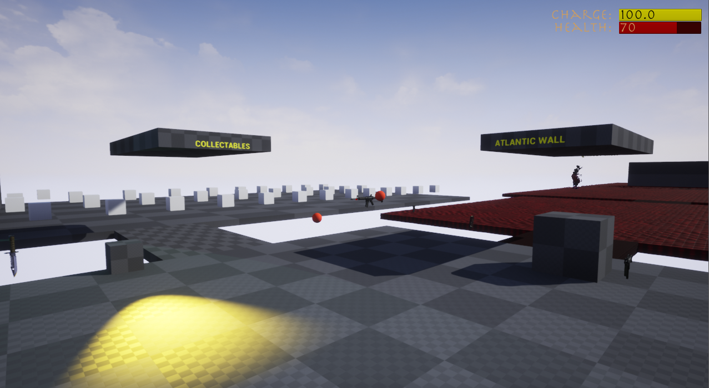

***Figure 1.3-2. Test Level: Collectables & Modified Atlantic Wall Areas***

**2 Usability Testing**

**2.1 Purpose & Breakdown**

The purpose of usability testing is to ensure that a range of users find the game usable, playable, and desirable. It is important that the user can learn the game easily and that the game is not hard due to controls, bad functionality, bugs, etc. Usability testing can help alleviate concerns or problems that may not arise during development and can create a better final product.

A usable game is one that the player can learn the controls without frustration and can easily understand them. A playable game is one that has few or no bugs, is not too difficult for the majority of players, and is enjoyable to play. Finally, a desirable game is one with nice user interfaces, good player interactions (such as shooting, reading text, using menus, etc.), and looks good overall.

Potential testers will be requested and any testers will be asked to fill out a consent form. Next, the tester will fill out a demographic questionnaire that will give insight into the tester’s information, but more importantly their brief history with video games. The tester will then play different parts of the game and give feedback during the play test if they wish. Once playing is finished, the tester will fill out a post-questionnaire about their experience and provide feedback based on their experience.

**2.2 Demographics**

It is important for Project Night Terror to be playable and appealing to a large demographic. However, the game does not have a specific demographic so the testing does not have any particular demographic to test for either.

**2.3 Testing Results**

**2.4 User Feedback**

**3 White Box Testing**

**3.1 Purpose & Breakdown**

The purpose of white box testing where the tester knows about the code behind the tests is to fine tune the game, fix bugs and problems as soon as they arise, and to ensure that common events that the user will encounter are tried. There was no specific tool used in this type of testing as it was all done inside the engine. The tests were created, performed by playing the game, and the functions being tested were improved based upon the results. Table 3.1-1 below shows the different areas were white box testing was used. Brief overviews of the areas that need to be tested are below as well.

**Guns**

All guns need to be tested to for firing and reloading. The weapon should only fire when the player has ammo, when the player has ammo in the magazine, and when they are not reloading. The weapon should only be able to reload when the player has ammo to reload and the magazine is either empty or not full. Shooting should also be accurate enough to give the player a realistic shooting experience.

**Melee Weapons**

Melee weapons need to be tested to check if attacking works by dealing damage and can only deal damage when the user is within a specific range from a demon.

**Flashlight**

As a core item in the game, the flashlight must be able to charge and lose charge at a constant rate. The flashlight must be off when it has no charge and on if the player choses to turn it on and there is a charge. Other features such as damage or effects to the demons also need to be tested.

**AI**

The AI must be able to attack the player and also deal damage to the player. The combat between the player and AI can be tested while testing multiple cases for the weapons, character, and AI itself.

**Pickups**

Ammo and health pickups should properly add to the player’s health or ammo only if those values are not currently maxed. If ammo or health is not maxed then the pickup increase should cause the player’s ammo or health to become their current amount plus the pickup amount or it should become the maximum amount if the difference is less than the pickup amount.

**Saving**

All player and level related variables and information must be saved when the player selects the save button. The player information also needs to be saved between levels or information will be lost when a new level is loaded. Saves must also be checked that they properly delete when the user wants to delete a save file. If it is not properly deleted than there will be unexpected results with loading.

**Loading**

All saved variables need to be checked upon loading to ensure that the proper player and level information is being updated when the player wants to play from a save. If a load is not properly implemented then the information lost could result in the player not having an item at that point, such as the flashlight in the last level, or a level may destroy an actor that it believes the player already has found.

**Perks**

Checked alongside item testing and health checks, when perks are selected the related variables and values are properly updated visually and in the back end.

**Objectives**

Tests need to check if objectives are being updated when specific tasks are completed such as completing a level, upon a level loading, or when a user picks up an objective related item. Without these tests, if an objective does not properly update then the user may become frustrated or confused. Objectives are critical as they are the main drive for the player on what to do or where to go. Levels are also designed to move to the next once all objectives are completed so a missed or bad test could create an instance where the player is unable to advance in the game.

***Table 3.1-1. White Box Testing List***



**3.2 Tests Performed**

Although a lot of testing is performed as the game has been developed, there are some specific tests performed on features such as the items. The rifle, pistol, cross, knife, and flashlight have been tested for boundary values and specific cases. For example, the rifle’s and pistol’s reload function needed testing to ensure that the could not reload if they have a full magazine or if they do not have enough ammo to fill the clip. On top of this, the reload function has the potential to affect or read the specific weapon’s total ammo, current magazine amount, and max magazine size. By checking specific cases, the reloading function was improved and situations that the player would commonly encounter, such as reloading at any point not just when the magazine is empty have been check to ensure there is no error. The rifle reloading testing table is shown in Table 3.2-1 and other item testing tables are shown in Appendix A.

***Table 3.2-1. Rifle Reload Function Test***



**4 Black Box Testing**

**4.1 Purpose & Breakdown**

The purpose of black box testing is to find problems that may not include code or does not require knowing the system behind the feature. For example, searching for a hole in the map requires no understanding on why or how that hole is there. This is important as there are gameplay elements or parts of the game that could affect the player’s experience if not found, tested, and/or resolved. Although many black box tests are covered by usability testing, it is important as the developer to ensure that all test cases in Table 4.1-1 are properly covered.

**Pickups and Visuals**

Tests that require a check for pickup need to ensure that the player can properly pick it up, that the item is destroyed, and that the item is added to the player’s inventory. For example, a note should prompt the user to pick it up then, upon the proper user action the note should disappear from the level and its information become visible to the player in the in game menu. Pickup checks go hand in hand with visual or audio that the user will hear or see since it is only available until after the user picks the item up or after a specific task is completed.

**Lighting**

Lighting tests are important as a level that is too dark can make a player frustrated that they cannot see; other problems such as strange or unrealistic reflections and shadows can also cause the player to have a lower quality experience.

**Player Movement and Controls**

Bad player movement, awkward controls, etc. can frustrate players, leave them confused, or lower player experience. Black box testing helps alleviate these concerns by checking player speed, animations, control placement, and more. Although listed in black box testing, this will be mostly covered in usability testing, as the testers will be covering these cases.

**Menus**

Menus need to work as intended and checking every single button in multiple ways ensures that the functionally properly works. Although most cases would be covered by the usability tests, the testers may not check every button or menu, which will leave specific parts untested. To avoid the lack of coverage, developer testing will include trying every user interface element.

**Characters**

The AI characters will need to be watched visually to check and see if they roam to places that were unintended such as out of bounds of the map, into level holes, etc. Since this does not relate to the actual functionality or code and is just visual, the only adjustments that testing will do to the characters will be level placement changes to the landscape, navigation bounds, BSPs, or static meshes.

***Table 4.1-1. Black Box Testing List***



**5 Automated Testing**

**5.1 Purpose & Breakdown**

Automated testing could lower the time it would take to test certain functionality of the game. However, there currently is no plan for automated testing as there is nothing deemed beneficial to test automatically as almost all functionally and gameplay will be done by the user. It would be more beneficial to have myself or others see the testing first hand to give more insightful feedback. If automated testing is added, it will be added here.

**Appendix A**

**Usability Tests**

**A.1**

**Appendix B**

**White Box Tests**

**B.1 Rifle Tests**

***Table B.1-1. Rifle Reload Function Test***



***Table B.1-2. Rifle Fire Function Test***



***Table B.1-3. Rifle Pickup Ammo Function Test***



**B.2 Pistol Tests**

***Table B.2-1. Pistol Reload Function Test***



***Table B.2-2. Pistol Fire Function Test***



***Table B.2-3. Rifle Pickup Ammo Function Test***



**B.3 Cross Tests**

***Table B.3-1. Cross Attack Function Test***



**B.4 Knife Tests**

***Table B.4-1. Knife Attack Function Test***



**B.5 Flashlight Tests**

***Table B.5-1. Flashlight Function Test***



**Appendix C**

**Black Box Tests**

**C.1 Collectables Tests**

***Table C.1-1. Note Testing***



***Table C.1-2. Audio Log Testing***



***Table C.1-3. Upgrades & Perks Testing***



***Table C.1-4. Artifact Testing***

